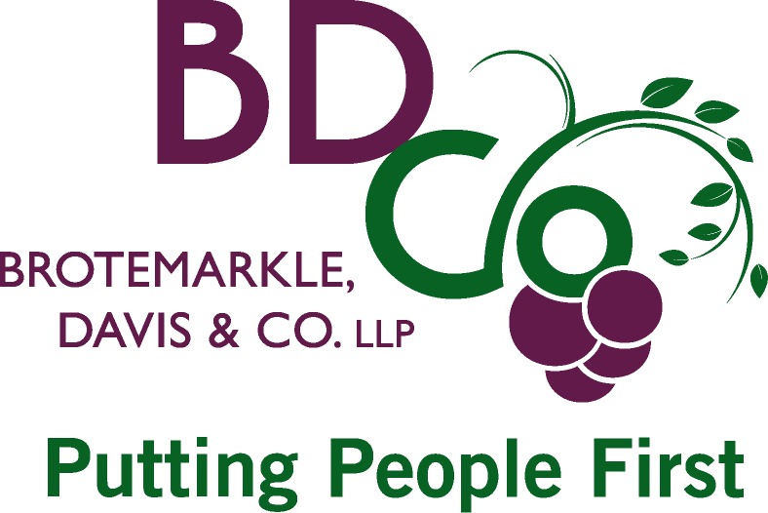

PHOTO RELEASE

I hereby give permission to [ your name here ] to use my name and photographic likeness for the BDCO Putting People First Photo Contest and use in their offices and on the www.bdcocpa.com website with proper identification.

Print Name:

Address:

E-mail:

Telephone:

Signature:

Date:

If Model is under 18: I, _______________________________, am the parent/legal guardian of the individual named above, I have read this release and approve of its terms.

Print Name:

Address:

E-mail:

Telephone:

Signature:

Date:

